This directory contains the Matlab code and test data for correcting uneven illumination.

How to use Correct_illumination_polygon:

1. Make sure to have the relevant directory in Matlab command window. Mark “add to path” when asked (see Fig.1).  
   * Preliminary steps: it is recommended to open a new folder, containing the individual frames from the time-lapse movie (you can save the individual frames in ImageJ/Fiji (file/save as/image sequence). Make sure to save the images as 16-bit.
2. Click “run”
3. A window will open, showing the 1st frame from the movie. Mark with the mouse the object of interest (for example, see Fig.2).
4. Matlab will then run the correction on each of the frames, saving it as “Analyzed#” (for example, Analyzed1, Analyzed2…). The consecutive images will be saved in the same folder as the original images.
5. Finally, you can open the new movie with fiji (import/image sequence OR: you can mark the images, drag them as separate frames to fiji window and then stack them). In case you still have intensity fluctuations, a fiji plugin (EMB tools/Bleach correction) can be used.

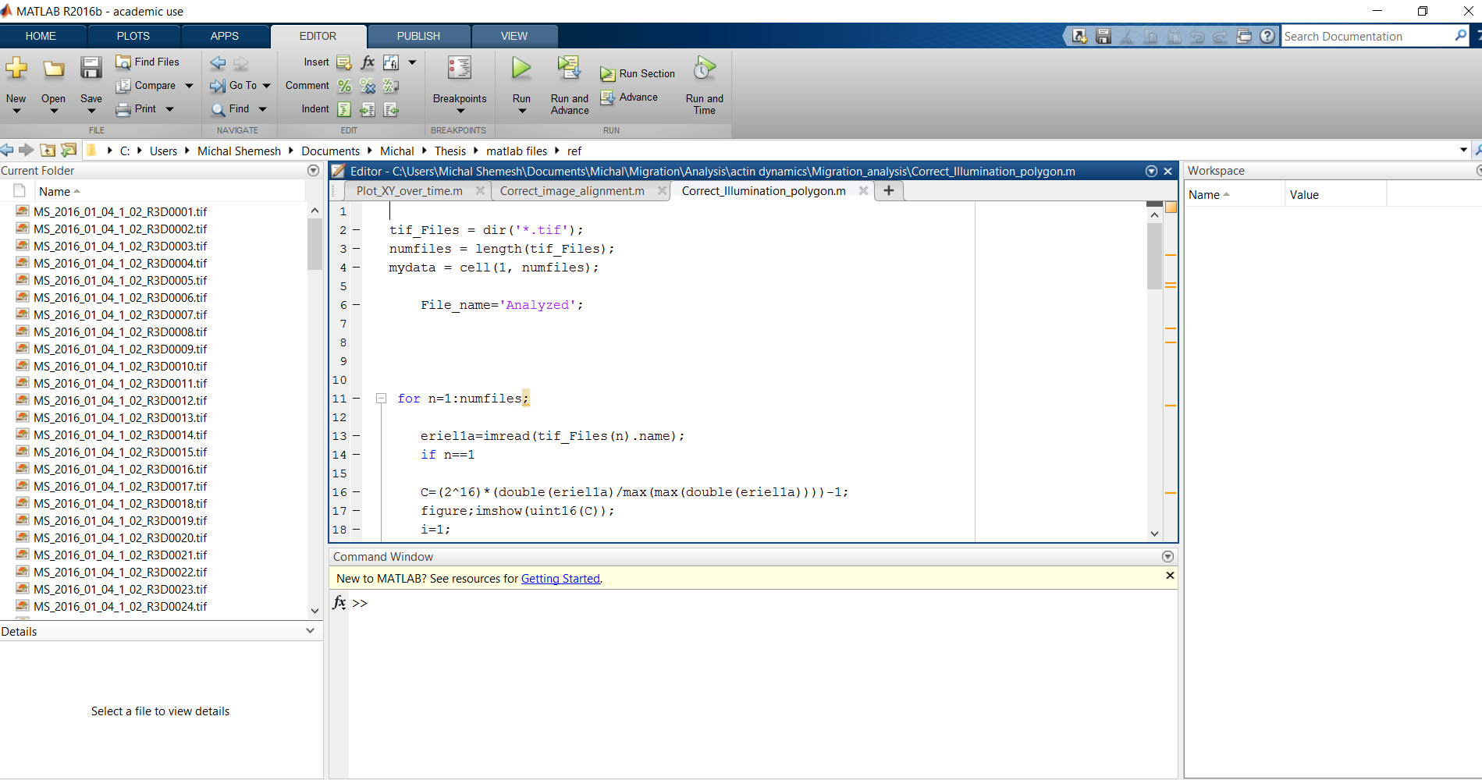

Fig.1: Snapshot of Matlab command window. The red circle marks the location where you need to enter the relevant directory.

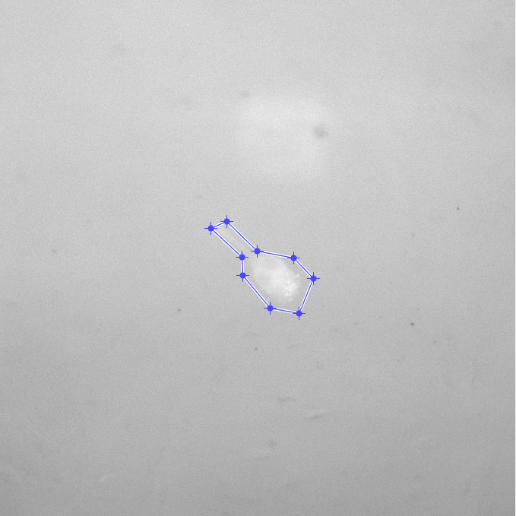

Fig.2: Exemplary image demonstrating the object marked in step 3.